UMM LA-QURA UNIVERSITY

COLLEGE TO ENGINEERING AND ISLAMIC

ARCHITECTURE

SUMMER TRAINING

PREPARED BY:

…………………………..

4300000000

Faculty of ………….. Engineering

TRAINED AT:

…………………………………………………………

FROM 12/07/2015 TO 01/08/2015 A.C

FROM 25/09/1436 TO 16/10/1436 HIJRAH

SUMMERYEAR: 2015 A.C, 1436 HIJRAH

SUBMISSION: / /

# Abstract

During the period from 12/7/2015 to 1/8/2015, I was sent to San Jose State University in the Silicon Valley for summer Training program. The program was called “Summer in Silicon Valley”. The whole purpose of the program was to make the participants experience the spirit of the Silicon Valley that is filled with innovation and cooperation and teach them how to work in a diverse team, effectively communicate and corporate together to achieve a common goal.

The activities done during the program can be mainly described under four categories:

* Lecture Sessions
* Field Trips
* Cultural Tours
* Team Projects

Each participant were assigned to a team consisting of persons from different backgrounds, different schools and different majors. During this period of time, I and my team were able to create a design and a business model under the title of “Ulife Water Purification System”. Our design have earned the first place in the eyes of judges thanks to all the contributions of all our team members. More details about the projects and each activity categories are coming in the next pages of this report.

This program was a wonderful experience for me that I will never forget. I learned a lot of things about Innovation and Entrepreneurship. I gain and improve my skills like working in a team and effectively communicating with others. I met unique individual and formed a strong friendships with them. This experience was very beneficial to me both on the personal level and on the carrier and knowledge level.

I would be happy to introduce you to this program in greater details through the pages of this report.

# Acknowledgement

At first I would like to thank the university president office, the vice-deanship of development & community service, the deanship of university development and quality, the college of engineering and Islamic architecture and the college of compute and information systems for their collaboration, full support of this program and their efforts to make this program a success. I also would like to thank all the staff of Charles W. Davidson College of Engineering for their support and guidance during the period of the program. A special thanks for Dr. Mohammed Thabit and Eng. Mohammed Fatein for joining us in this trip and for guiding us.

# Table of Contents

[Abstract I](#_Toc489189071)

[Acknowledgement II](#_Toc489189072)

[Table of Contents III](#_Toc489189073)

[Chapter One – Introduction 1](#_Toc489189074)

[1.1 Company Background 1](#_Toc489189075)

[1.2 Student’s Work assignment 1](#_Toc489189076)

[1.3 Training Objective 2](#_Toc489189077)

[Chapter Two - Lecture Sessions 4](#_Toc489189078)

[2.1 Creating Successful Teams 4](#_Toc489189079)

[2.2 History of Silicon Valley and its High-Tech Companies 6](#_Toc489189080)

[2.2.1 History of Silicon Valley 7](#_Toc489189081)

[2.2.2 Fund Rising 9](#_Toc489189082)

[2.3 Innovation through Analytical Problem Solving 10](#_Toc489189083)

[2.3.1 Contamination 10](#_Toc489189084)

[2.3.2 Mechanical Properties 11](#_Toc489189085)

[2.4 Entrepreneurship & Business Models 12](#_Toc489189086)

[2.4.1 Start-ups 12](#_Toc489189087)

[2.4.2 Entrepreneur 12](#_Toc489189088)

[2.4.3 Entrepreneurship 13](#_Toc489189089)

[2.4.4 Business Model 13](#_Toc489189090)

[2.5 Effective Communication in the Modern Workplace 14](#_Toc489189091)

[2.6 Presentation Skills 15](#_Toc489189092)

[2.7 Hoverboard Technologies a Start-up Company 15](#_Toc489189093)

[Chapter Three - Field Trips 16](#_Toc489189094)

[3.1 Intel Corporation 16](#_Toc489189095)

[3.2 The Tech Museum of Innovation 16](#_Toc489189096)

[3.3 San Francisco Exploratorium 17](#_Toc489189097)

[3.4 Evans Analytical Group 17](#_Toc489189098)

[3.5 Computer History Museum 17](#_Toc489189099)

[Chapter Four - Cultural Trips 19](#_Toc489189100)

[4.1 Santa Cruz Beach Boardwalk 19](#_Toc489189101)

[4.2 San Francisco Golden Gate Park 19](#_Toc489189102)

[Chapter Five - Team Project 20](#_Toc489189103)

[5.1 Design 20](#_Toc489189104)

[5.2 SWOT analysis: 22](#_Toc489189105)

[Chapter Six - Conclusion and Recommendations 24](#_Toc489189106)

[6.1 Conclusion 24](#_Toc489189107)

[6.2 Recommendation 24](#_Toc489189108)

[References 26](#_Toc489189109)

# Table of Figures

[Figure ‎1‑1 High-Tech Companies in Silicon Valley 1](#_Toc489191034)

[Figure ‎1‑2 Summer in Silicon Valley Schedule 2](file:///C:\Users\century\Dropbox\وكالة%20التدريب%20والعلاقات%20الصناعية\Unused%20Folders\Summer%20Silicon%20Valley\Silicon%20vally%20report%20&%20lectures\2nd%20Training%20Report.docx#_Toc489191035)

[Figure ‎2‑1 History of Silicon Valley Timeline 7](#_Toc489191036)

[Figure ‎2‑2 The Garage Hewlett and Packard worked in to develop their first product 7](file:///C:\Users\century\Dropbox\وكالة%20التدريب%20والعلاقات%20الصناعية\Unused%20Folders\Summer%20Silicon%20Valley\Silicon%20vally%20report%20&%20lectures\2nd%20Training%20Report.docx#_Toc489191037)

[Figure ‎2‑3 The Traitorous Eight 8](file:///C:\Users\century\Dropbox\وكالة%20التدريب%20والعلاقات%20الصناعية\Unused%20Folders\Summer%20Silicon%20Valley\Silicon%20vally%20report%20&%20lectures\2nd%20Training%20Report.docx#_Toc489191038)

[Figure ‎2‑4 Fairchild’s 1st microchip. combined 4 transistors, 6 resistors & interconnecting wires on a sliver of silicon 8](file:///C:\Users\century\Dropbox\وكالة%20التدريب%20والعلاقات%20الصناعية\Unused%20Folders\Summer%20Silicon%20Valley\Silicon%20vally%20report%20&%20lectures\2nd%20Training%20Report.docx#_Toc489191039)

[Figure ‎2‑5 Different kind of test done by EAG 10](file:///C:\Users\century\Dropbox\وكالة%20التدريب%20والعلاقات%20الصناعية\Unused%20Folders\Summer%20Silicon%20Valley\Silicon%20vally%20report%20&%20lectures\2nd%20Training%20Report.docx#_Toc489191040)

[Figure ‎2‑6 Instron 11](file:///C:\Users\century\Dropbox\وكالة%20التدريب%20والعلاقات%20الصناعية\Unused%20Folders\Summer%20Silicon%20Valley\Silicon%20vally%20report%20&%20lectures\2nd%20Training%20Report.docx#_Toc489191041)

[Figure ‎2‑7 Stress Strain Curve 11](#_Toc489191042)

[Figure ‎2‑8 Business Plan Canvas 13](file:///C:\Users\century\Dropbox\وكالة%20التدريب%20والعلاقات%20الصناعية\Unused%20Folders\Summer%20Silicon%20Valley\Silicon%20vally%20report%20&%20lectures\2nd%20Training%20Report.docx#_Toc489191043)

[Figure ‎2‑9 Customers Development Process 13](file:///C:\Users\century\Dropbox\وكالة%20التدريب%20والعلاقات%20الصناعية\Unused%20Folders\Summer%20Silicon%20Valley\Silicon%20vally%20report%20&%20lectures\2nd%20Training%20Report.docx#_Toc489191044)

[Figure ‎2‑10 The Agile Process 13](file:///C:\Users\century\Dropbox\وكالة%20التدريب%20والعلاقات%20الصناعية\Unused%20Folders\Summer%20Silicon%20Valley\Silicon%20vally%20report%20&%20lectures\2nd%20Training%20Report.docx#_Toc489191045)

[Figure ‎3‑1 Demonstration of the Clean Room in Intel Laboratories 16](file:///C:\Users\century\Dropbox\وكالة%20التدريب%20والعلاقات%20الصناعية\Unused%20Folders\Summer%20Silicon%20Valley\Silicon%20vally%20report%20&%20lectures\2nd%20Training%20Report.docx#_Toc489191046)

[Figure ‎4‑1 The View of Golden Gate Bridge from Baker Beach 19](file:///C:\Users\century\Dropbox\وكالة%20التدريب%20والعلاقات%20الصناعية\Unused%20Folders\Summer%20Silicon%20Valley\Silicon%20vally%20report%20&%20lectures\2nd%20Training%20Report.docx#_Toc489191047)

[Figure ‎5‑1 Ulife Design 21](#_Toc489191048)

[Figure ‎5‑2 Cross-Section of Ulife Design 21](#_Toc489191049)

[Figure ‎5‑3 SWOT Analysis 23](file:///C:\Users\century\Dropbox\وكالة%20التدريب%20والعلاقات%20الصناعية\Unused%20Folders\Summer%20Silicon%20Valley\Silicon%20vally%20report%20&%20lectures\2nd%20Training%20Report.docx#_Toc489191050)

# Chapter One – Introduction

## Company Background

My training was at Charles W. Davidson College of Engineering at San Jose State University. San José State University is a comprehensive public university located in San Jose, California, United States. It is the founding school of the 23 campus California State University (CSU) system, and holds the distinction of being the oldest public institution of higher education on the West Coast of the United States. [1] [2] Charles W. Davidson College of Engineering play a great role of graduating a very considerable percentage of engineers working at the companies of the Silicon Valley.

The Silicon Valley is well known as the source of most of nowadays technologies. Lots of current high-tech companies started there and have their headquarters established in Silicon Valley. Figure 1

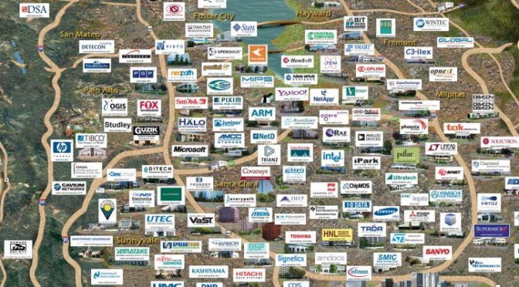

Figure 1‑ High-Tech Companies in Silicon Valley

## Student’s Work assignment

Participants of this program were expected to commit to the Program schedule (Figure 1-2), attend and participate in all the activities of the program and always be on time. The activities of the program as mentioned before are:

* Lecture Sessions
* Field Trips
* Cultural Tours
* 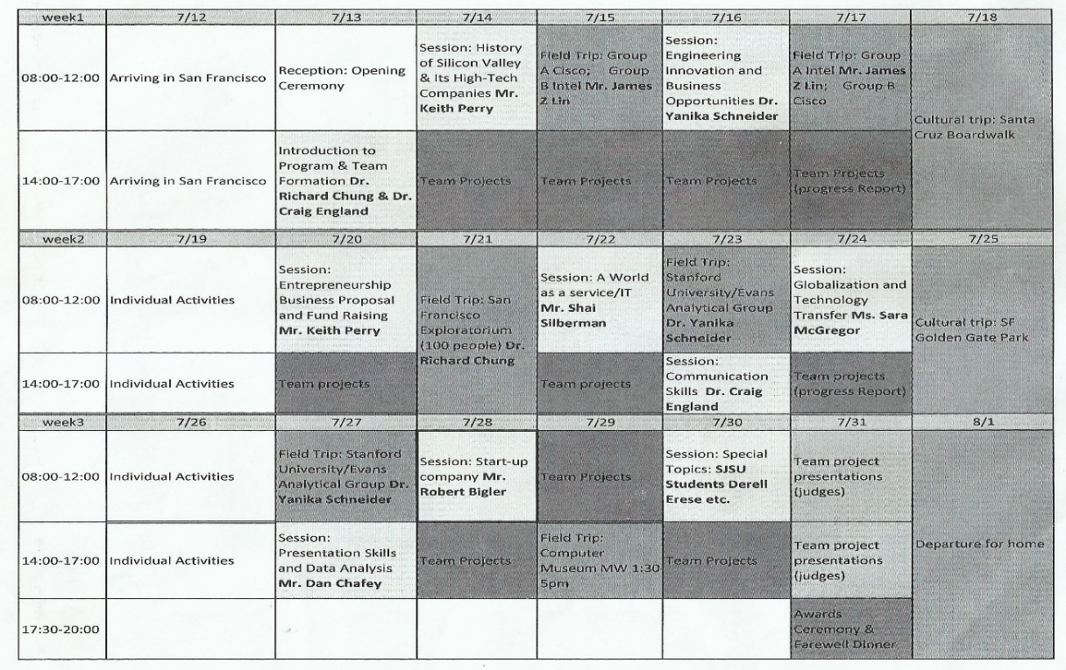Team Projects

Figure 1‑ Summer in Silicon Valley Schedule

Participants were expected to work on projects with their teammates, brainstorm, analyze, communicate and perform tasks to realize the objectives and goals of their project.

## Training Objective

The objective of summer in Silicon Valley weren’t to gain technical knowledge or experience in the field of Engineering but to learn more about innovation and entrepreneurship and improve skills like teamwork and communication. Here are the main objectives of summer in Silicon Valley training:

* Learn from instructors about product innovation, technology transfer, engineering entrepreneurship, and multicultural education
* Engage in project team activities by collaborating with international students participating in program
* Observe innovative processes by visiting Silicon Valley high technology companies
* Explore Silicon Valley Culture by touring San Francisco Bay Area

# Chapter Two - Lecture Sessions

Lecture Session were one of the main activities of summer in Silicon Valley training program. They provided participant with knowledge and taught us more about Silicon Valley, entrepreneurship and business models and communication skills. They also delivered the experiences of some of those who are working on the field and the role played by their companies in the society and the industry.

In This chapter I will explain those lectures and what I learned from them in greater details.

## Creating Successful Teams

Creating Successful Teams, a lecture presented by:

Dr. Craig England  
Biomedical, Chemical and Materials Engineering Department  
San Jose State University  
San Jose, California

A lecture about the reasons some teams fails and how to avoid it and create successful teams. I will share the outline of the lecture and the general ideas without going too deep into details.

Outline:

* Seven key reasons teams fail
* What teams can do to prevent failure
* Characteristics of a successful team

Seven key reasons team fails and how to solve them:

1. No clear direction and goals

* Create a vision statement
* Create a team mission statement
* Establish goals

1. Failure to formalize roles and responsibilities

Form Team roles:

* Team Leader
* Team recorder

1. Unable to conduct effective meetings

* Establish a concrete meeting agenda
* Start and end meetings on time
* Create an atmosphere for participation
* Avoid dominance by any individual team member
* Assign responsibilities and evaluate effort
* Establish a communication plan

1. No problem-solving and decision-making processes

Problem solving process

* Define the problem
* Analyze the problem
* Develop solutions to consider
* Choose a solution
* Implement an action plan
* Evaluate and adjust

Decision-making process:

* Allow adequate time for the process
* Do not simply vote or flip coins
* Ensure that everyone’s viewpoint is heard
* Understand that conflict, negotiation and collaboration are essential to the process
* Observe that every member is comfortable with the decision
* Make sure that everyone accepts and supports the decision
* Realize that consensus is hard work

1. No conflict resolution process

Managing conflict:

* Tolerate conflict when it allows member to change and grow, allows them to better understand each other or increases creativity and innovation.
* Intervene to resolve conflict when it detract from the team goal, polarize the team, involve personal attacks or attack the value of the team

Conflict resolution:

* Explore the root of the conflict
* Explore alternate solutions
* Find a solution that all parties can support
* Implement the solution
* Revisit the conflict

1. Inability to identify and use individual members’ skills

* Develop a method in which team member can identify and share their individual skills.
* A personality/skills evaluation tool can be used to help identify the strengths and weaknesses of each team member.

1. Lack of well-developed procedures for communication

* Agenda and minutes of all team meetings
* Action plans and reports
* Regular progress reports
* Use technology to enhance communication

Finally, the characteristic of a successful team is described with this acronym developed by Ken Blanchard:

**Purpose**

* **P**urpose
* **E**mpowerment
* **R**elationship and Communication
* **F**lexibility
* **O**ptimal Performance
* **R**ecognition and Appreciation
* **M**orale

## History of Silicon Valley and its High-Tech Companies

Presented by Dr. Keith Perry.

This lecture contained three parts. First the history of Silicon Valley and second an introduction about funds rising.

### History of Silicon Valley

The Silicon Valley used to be an area specialized in food production and Agriculture. However all changed as time goes. Here’s the time line for the most important event in the history of Silicon Valley.

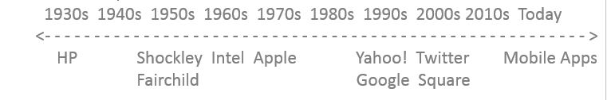

Figure 2‑ History of Silicon Valley Timeline

#### HP (Hewlett-Packard Company). 1938

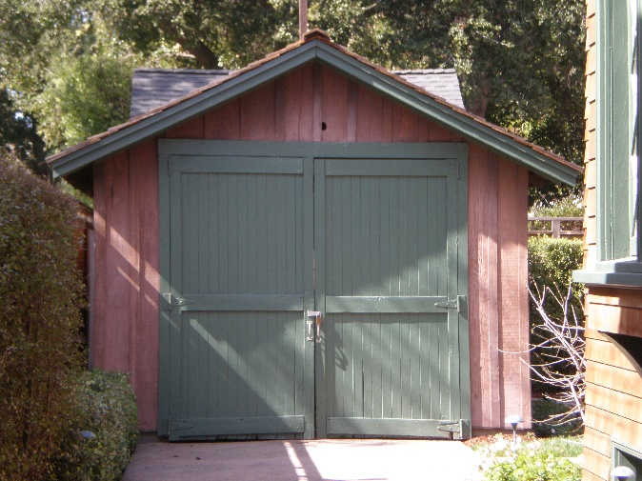The first event that helped forming the Silicon Valley to what it become today and the one believed to be the birth of Silicon Valley is the foundation of HP in 1938 when William Hewlett and David Packard start developing their first product an audio oscillator in a one-car garage nearby Palo Alto after being encouraged by their teacher, professor Frederick Terman, a professor at Stanford university who encouraged his students to create their own tech companies In the west coast instead of joining other already established companies in the east.

Figure ‎2‑2 The Garage Hewlett and Packard worked in to develop their first product

#### Shockley Semiconductor Laboratory. 1956

in 1956 William Shockley and two other scientist were able to create the first transistor and found Shockley semiconductor laboratory. They earned 1956 Nobel Peace Prize in Physics.

Shockley begin working on other projects so he recruited more employees to work with him. However due to lack of trust and intolerable working conditions the project failed and 8 of the employee left the intuition. They were Gordon Moore, C. Sheldon Roberts, Eugene Kleiner, Robert Noyce, Victor Grinich, Julius Blank, Jean Hoerni and Jay Last. Those 8 employee also known as the Traitorous Eight.

#### 400px-The_Traitorous_Eight.jpgFairchild Semiconductor 1957

The Traitorous Eight reached an agreement with Sherman Fairchild and created Fairchild Semiconductor In 1957. Fairchild Semiconductor were able to create the first successful integrated circuit, a compete electronic circuit inside a silicon chip.

#### More Companies:

Figure 2‑ The Traitorous Eight

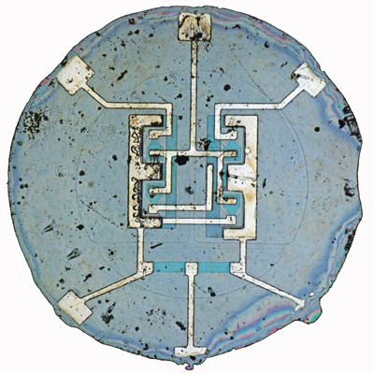More companies have been founded after that providing more technologies, products and services which raised the level of competition in Silicon Valley. Most notable examples are:

* Intel. Founded by Robert Noyce and Gordon Moore in 1968. They became one of the world's largest and highest valued semiconductor chip makers.
* Apple. Founded by Steve Jobs, Steve Wozniak, and Ronald Wayne in 1976. World’s most valuable company. They focus on Computers, Phones, iTunes Store and Items and systems that connect all of these together.

Figure ‎2‑4 Fairchild’s 1st microchip. combined 4 transistors, 6 resistors & interconnecting wires on a sliver of silicon

* Yahoo. Founded by Jerry Yang, David Filo in 1994.
* Google founded by Larry Page and Sergey Brin in 1998
* Twitter founded in 2007 by Jack Dorsey, Evan Williams, Biz Stone and Noah Glass
* Square founded in 2009 by Jack Dorsey and Jim McKelvey
* More and more companies are being found providing more services, product that uses new technologies and mobile apps.

### 

### Fund Raising

#### Initial Public Offering, Other companies

Shares of stock in a company are sold to institutional investors who in turn sell them to the general public on a securities exchange (e.g. NYSE, NASDAQ). Company selling shares is never required to repay. This transforms a private company into a public one as shares trade freely in the open market between public investors

#### Venture Capitalists (VC)

Venture capital (VC) is money provided to seed, early-stage, emerging and emerging growth companies. The venture capital funds invest in companies in exchange for equity in the companies it invests in, which usually have a novel technology or business model in high technology industries, such as biotechnology and IT

#### Angels

Angels provide the same service as venture capitalists to starting businesses the only differences are:

* They Involve in earlier stages
* They provide Smaller investments than VCs
* Typically one or small group of investors
* Angels take a more active role in mentorship

#### Accelerators and Incubators

Accelerators Provide seed investment and mentoring to start-up companies. Helping scaling up the business and do the work of years in months “accelerating”. Incubators help start-up companies innovate their ideas, start their business and start growing by providing required infrastructure like office spaces, internet, phones, etc. Main differences between Accelerators and incubators are:

Accelerator

* Intensive mentoring & training
* Cohort based fixed term education
* Phases: awareness, application, program, demo day, post demo day
* Private or government funded

Incubators

* Provide infrastructure
* Office space
* High speed internet
* Phones, etc.
* Rub shoulders with other startups
* Volunteer advisors, guest speakers

## EAG letterhead header 9 25 2005Innovation through Analytical Problem Solving

Lecture presented by Yanika Schneider, a Scientist working at Evan Analytical Group (EAG). The lecture was more about what her company do and what services they provides to their customers

EAG was established in 1978 in Silicon Valley, California. They have over 20 locations in 7 countries, they use more than 40 analytical techniques of analyzing. They have over 300 instruments and about 1200 scientists, engineers and support. They employ career scientists, many with Ph.D.

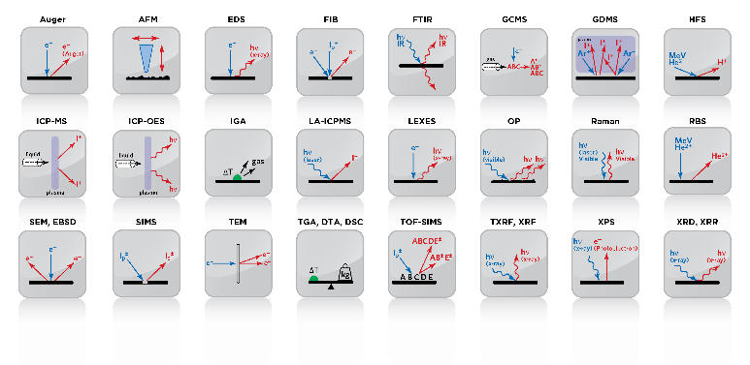Evan provide analyzing services for their customer. Their customer develop a product and they provide a prototype to EAG. The prototype go through a lot of tests in EAG laboratories that equipped with high-tech and very expensive test instrument to find any kind of failure weather it is a contamination failure or mechanical failure. After that EAG scientists analyze the provided data from the test to find if there is any failure or defect in the product. They look for the reasons of the failure if exist and find a solution for it.

Figure 2‑ Different kind of test done by EAG

### Contamination

One of the main failure in product is contamination failure, when there is an unwonted substance in the product that could be harmful to users. Contamination failure could be either organic on inorganic. Each one have different methods to detect. For organic contamination they use FTIR (Fourier Transform infrared) or Raman Spectroscopy. For inorganic contamination they use SEM/EDX, AES and XPS.

### Mechanical Properties

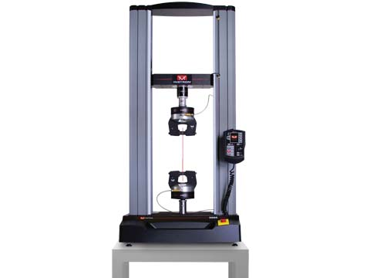Some tests are done to the product to test different criteria like:

* Toughness
* Strength
* Hardness
* Durability
* Elasticity
* Viscosity

Those criteria can be tested using Instron (Figure 8 Instron) that provide stress strain curve ().

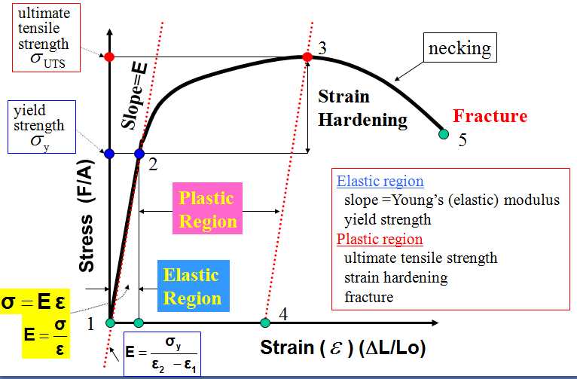

Figure 2‑ Instron

Figure 2‑ Stress Strain Curve

## Entrepreneurship & Business Models

Presented by Keith Perry

The lecture was about entrepreneur personality and qualities, entrepreneurship and major differences between big companies and start-ups and the design of a business model.

### Start-ups

Since we are talking about entrepreneurship let’s talk first about start-ups and what are the possibilities of their future.

When a new group of people start their small business. Their business might:

* Grow into a company
* Pivot and iterate as it continues to search for a business model.
* Grow very slowly and barely break even
* Run out of money and shut down

The main reasons a startup might fails includes:

* Cofounders fight.
* They can’t build initial specification for their product/services.
* They get no funding
* Too few people buy or use the product.

### Entrepreneur

One should consider if they have what it takes to be an entrepreneur when they decide to start a business. Some of the main personal qualities of an entrepreneur are:

* Motivation to achieve
* The Habit of hard work
* Nonconformity
* Strong leadership
* Stress smart
* Compulsive gambling
* High risk taking
* Compulsive hip shooting

One of the ways one can evaluate themselves if they could make a good entrepreneur or not is to use the Myers-Briggs type indicator.

### Entrepreneurship

At first let’s turn the light onto the main differences between companies and start-ups.

The main differences is that start-up need to search for a business plan. They need to find a good plan to serve their customers and profit from it. On the other hands an already established enterprise already have their business plan they only need to keep executing their plan repeatedly.

We will focus our attention to what start-up have to do to create their successful business plan.

#### Strategy

Figure 2‑ Business Plan Canvas

One of the best ways to develop a business plan is to use the business model canvas. Start planning and filling the blanks. Who are the customers and what are their needs? What resources are needed? Who are the potential key partners? Go outside and test these theories and plans. Do they fit the reality? Are your customers and their needs the way you anticipated? After that comes the developing of the operation plan and the financial forecast.

#### Process

Figure 2‑ Customers Development Process

The first thing that comes in the process of starting up a business is to identify the customers and their needs, since most of failing start-ups are due to lack of customers not the failure of the product. That’s why customers development process is followed so customers’ needs is always in check. **Error! Reference source not found.**

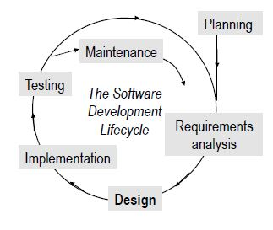Other than that the whole process of working on starting up a business can be explained in the agile process. Figure 12

Figure 2‑ The Agile Process

### Business Model

The business model is the way (the how) the company is going to create value for itself while delivering products or services for customers.

As mentioned before one of the best ways to develop the business model is by using the business model canvas (**Error! Reference source not found.**). I will explain the terms used in the canvas in brief.

* Value proposition: What is the value presented by the company to the customers? What problems is going to be solved and what needs is going to be satisfied?
* Customer Segments: Who are the customers? Where are they? What are the demographics? What is the persona? And why would they buy the product?
* Channel: How is the company going to deliver the product and services to the customers?
* Customer Relationships: How does the company get, keep and grow their customers?
* Revenue Streams: The way the company is going to profit and get money. Including many things like revenue model and pricing tactics
* Key Resources: All the resources needed to make the business works, including financial resources like funding, infrastructure needed, intellectual resources like patents and human resources.
* Partners: The key partners and suppliers needed to make the business model work, the key recourses they can provide and the key activities they can perform.
* Key Activities: The most important activities the company must do in order to make the business work
* Costs: they includes the most important costs, most expensive costs, the most expensive key activities.

## Effective Communication in the Modern Workplace

A lecture presented by Dr. Craig England.

Communication is very important for teams and individual to work together and to achieve their goals. For improving the effectivity of our communications we need to understand the underlying factors affecting our communications, like our personality types, different types on intelligence and job skills. Better understanding of those factor help improve our communications. One of the ways to determine the personality type of each individual is to use Myers-Briggs Type Indicator which uses four two-factor scales to classify individuals as one of 16 personality types and the theory of mutable intelligences

## Presentation Skills

Presented by Mr. Daniel Chafey. A lecture about some the skills related to presentation.

Most important thing when presenting is first to identify the type of audience you are going to present to, the type of presentation you are going to give and the required details for the presentation. Identifying those and understanding them will help communicate our ideas we want to present to the audience.

This lecture also included many tips for making the slides more appealing and clear to the audience and demonstrated the importance of appearance and body language.

## Hoverboard Technologies a Start-up Company

*“I am totally okay with failing”*

*-Robert Bigler*

A lecture season presented by Robert Bigler, an inventor and entrepreneur that have been working on the field for a long time. He introduced his past work to us which was the design of a motor combined with a control system that allow the user to program it to do different functions called Smart Motor. His first product didn’t profit and he and his company decided to sell their design to their competitor MOOG Animatics to compensate for the losses. [3]

Their second project was Robert dream and vision for years. They wanted to invent a hover board. A board that fulfill the science-fiction dream of many people of riding a hover board. Although it is not a board that hover, it is a board that gives the experience similar to hovering. [3]

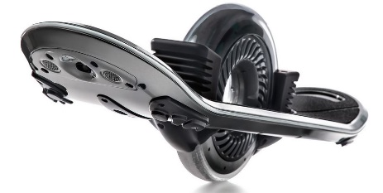The design of the board consist of a board and a big one wheel in the middle of the board. It can cover a range of 12 miles with a speed of 16 mile per hour. It weigh around 25 pounds. The battery can be fully charged in 18 minutes. They are planning to get funding for their project using Kickstarter campaign that they are going to lunch in September 17, 2015. They are going to distribute their product in United States and different Southeast Asia counties. More details about the product can be found in Hoverboard website: <http://hoverboard.com>

Figure 2.11 Hoverboard

# Chapter Three - Field Trips

## Intel Corporation

*“Don’t be encumbered by history. Go off and do something wonderful.”*

*-Robert Noyce*

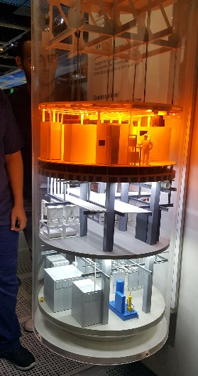On 14th of July. We were separated into two groups. One went into a field trip to Cisco Corporation and the other went to Intel. I was with the second group. We picked the bus at 8:30 am and moved to Intel headquarter in San Jose. We arrive there around 9:00 am. At first we took a tour around the offices of the building. It was more like a maze! Very huge building. We kept going on our tour until we reached a lecture room, where Mr. James Z. Lin gave us a brief introduction about the company, what they are doing and the different fields their team work in. after another long walk in the huge building we visited the Intel museum. We were able to see the first processors Intel every made, the IBM compute powered by Intel processor, different fun experiments and lastly the process they use to create their processors. It was a fun and a very educational trip.

## The Tech Museum of Innovation

Figure 3‑ Demonstration of the Clean Room in Intel Laboratories

In the morning of 17th of July, we moved from the campus of San Jose State University to the Tech Museum of Innovation in located in downtown San Jose, 4 blocks away from the campus. We arrived at the museum around 10:15 am. The Tech Museum introduces innovational ideas, scientific facts and other kind of knowledge with a fun way that fit people from all different ages and backgrounds whether it was with playing games, with group activities or experiments. The Museum was huge and time wasn’t enough to see everything

## San Francisco Exploratorium

San Francisco Exploratorium is located in San Francisco California. It has a similar concept compared with the tech museum of innovation of introducing general knowledge and interesting information about different field with experiment and fun way. We rode the bus from San Jose campus around 9:03 am and arrived around 10:29 am. The Exploratorium was huge and have many section in all fields including electricity and magnetics, Biology Mechanics and optics. The trip was both fun, informative and inspirational.

## Evans Analytical Group

As I mentioned before in Chapter 3, Evan Analytical Group provide the service of making tests on the customer product and analyzing the acquired information to fix failure if exist and to improve the product.

On 23rd of July we went to see their laboratory in Sunnyvale, California. Dr. Yanika and her collogues took small groups of us into tours to show us different instrument they use in their tests. I saw a lot of instruments that is used to produce data that cost millions, which is the main service they provide. They provide instrument, expertize and analysis of the date acquired by the test instruments to their customers.

They also introduced us to their circuit test labs where they detect faults in circuit design and material of the circuit.

*“The best way to predict the future is to invent it”.*

*Alan Kay, 1971*

## Computer History Museum

We visited the computer history museum on 29th of July. It is located in Mountain View, California. Computer Science Museum introduce whole history of computer. From the creation of ancient calculators though the mechanical computer to the electrical computer we know today. I saw the difference of old computers compared to nowadays computers. The transition from vacuum tubes to transistors, and how the space required to store data have changed from big rooms to small chips.

Although the computer development have been strongly related to wars throughout history, it have become a tool of making people lives more convenient.

Another lesson to learn from this experience that the creation of computer wasn’t the deeds of one person but the contributions of many people who have been working to advance this technology even further throughout all the history. This technology still improving every day.

# Chapter Four - Cultural Trips

Cultural Trips wasn’t for adding new knowledge or learning new skills, but simply to have fun spending the weekend. Since it was three weeks we had to two cultural trips at the end of each week on Saturdays, except of the last Saturday which was the departure of home.

## Santa Cruz Beach Boardwalk

First cultural trip was to Santa Cruz Beach Boardwalk on Saturday, July 18. Santa Cruz is a small town to the south of San Jose. The boardwalk was on the beach of Santa Cruz. There was also an amusement park on the beach. All participants separated into small groups and doing their own activities during the trip. We enjoyed it.

## San Francisco Golden Gate Park

Figure 4‑ The View of Golden Gate Bridge from Baker Beach

Second cultural trip was to San Francisco Golden Gate Park, located in San Francisco on Saturday, July 25. The Golden gate park is estimated to have an area of 4,115,653 m2. In the golden gate park you can find gardens, playgrounds, lakes, picnic groves, trails, and monuments, plus an array of cultural venues, events, and activities. Through this trip we have split into smaller groups. Each group went on their own journey inside of the golden park and in different places around San Francisco. I and my group went into a small tour around the park than we walked for 45 minutes until we reached Baker beach. We were able to have a nice view of the Golden Gate Bridge. After spending some time on the beach we moved to visit San Francisco China Town. The trip was both amusing and refreshing.

# Chapter Five - Team Project

One of the main objective of the SSV program was to make the participants experience working together in teams to develop a product, going through the different stages of the innovation process and create a business model for their product.

My team was called team Arrow. Our assistant and group facilitator was Darrell Erase. The team consisted of 8 members form different schools and area of expertise. They were unique and hardworking individuals. I am glad that I’ve met them worked with them and formed friendship with them. We had a great time working on this project together. The following table contains some details about the team members:

Our project was to design a portable water purification system. We have designed and we called it Ulife.

Ulife was designed to solve the problem of unclean water that people living in poor areas, remote areas or disaster areas face. People living in these kind of areas suffer from lack of clean water sources. Many people die every year because of diseases related to water. Ulife is a portable water purification device that can clean dirty water from any water source.

## Design

We went through a long process of brainstorming, generating ideas, doing research and forming consensus. We have generated a lot of ideas that could solve this problem effectively and make an affordable desirable product to our customers. Some of these ideas were creative and unique. Our main criterial for the product was to make it effective affordable and easy to use and carry. After all this process we reached the final design of Ulife. Below.

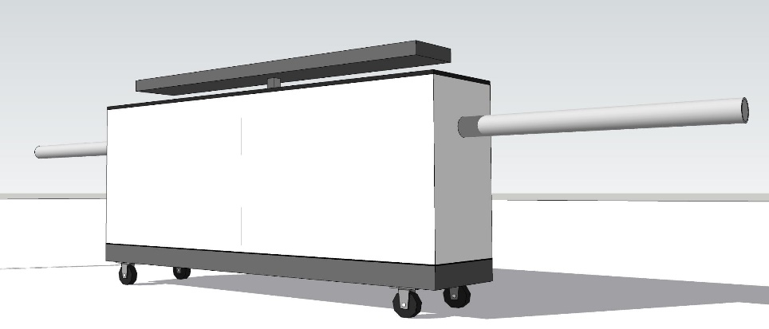

Figure 5‑ Ulife Design

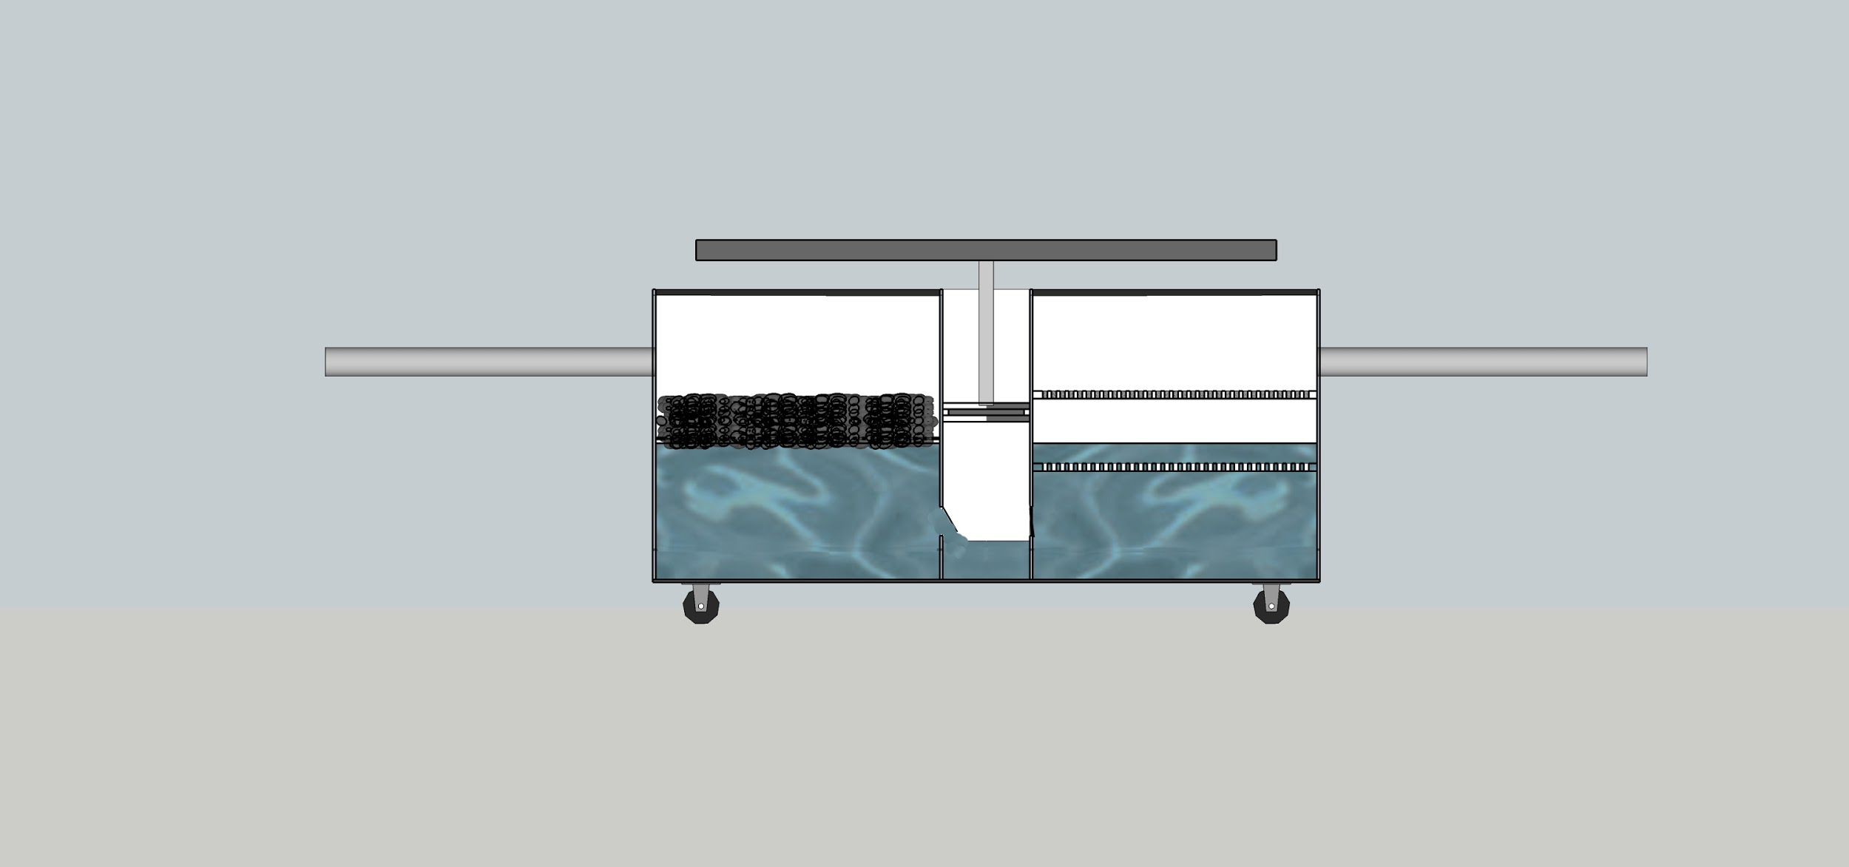

Figure 5‑ Cross-Section of Ulife Design

The final design of Ulife is a pump that takes water form a dirty source using a mechanical force, passing it through a physical filter and then through another filter of Zinc oxide material. The first filter is a normal physical filter that is used to take out small solids and particles of the water like stones and sand. The second filter is a filter consist of zinc oxide. Zinc oxide has some chemical properties that makes it perfect to clean water and kill any harmful bacteria or viruses that considered a treat to human health. The effect of zinc oxide (ZnO) on water can be enhanced by sun light or any other type of light to produce cleaner water with even better PH level. Both filters can be changed after they are filled with dirt. Ulife can produce clean drinkable water from any water from any water source.

Ulife is light-weight. It can be easily carried to any water source to start the water purification process, giving it a huge advantages over other water purification devices that can’t be moved from its position due to heavy weight. Ulife is made of cheap materials making it affordable for our target customers – people living in poor areas.

## SWOT analysis:

Strengths:

1. Our product is cheap.
2. New materials (ZnO) and methods with high efficiency.
3. Portable
4. We have technical personnel from all over the world.
5. We have good organized departments and disciplines.

Weaknesses:

1. We cannot get huge profits from Africa.
2. As a startup, we cannot get enough funding from different kinds of channels.
3. Our product is new and many technical problems need to be solved.
4. Hard to keep steps in the same time because of international division.

Opportunities:

1. Chinese governments spend a lot of money supporting startups.
2. Plenty of laws and regulations have already been utilized to guarantee successful startups.
3. Shipping cost is vanished because of PVC cooperator in Africa
4. Low material costs (ZnO) in South Korea
5. Globalization. (Effectively using best resources all over the world)
6. CHNA-AFICA relationship.
7. Large quantities of potential customers in Africa

Threats:

1. Numerous competitors
2. Not easy to cooperate with Chinese gov.
3. 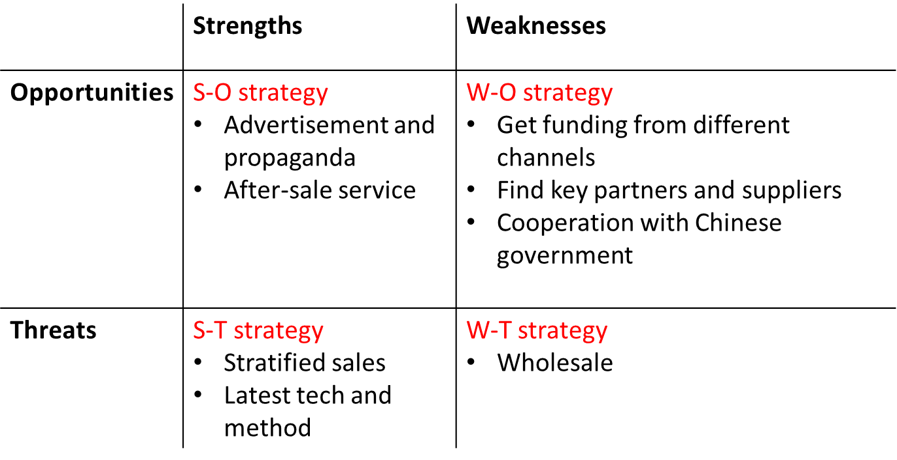Supply Chain

Figure 5‑ SWOT Analysis

Key Partners:

1. SASOL as PVC supplier
2. Ciyang Technology Company as zinc oxide supplier.
3. Water organization
4. Charity water organization.

# Chapter Six - Conclusion and Recommendations

## Conclusion

In the end of summer in Silicon Valley, I can’t say I’ve learned much of technical information related to my major; however I can’t deny the huge positive impact of the experience and over all benefits of it. The main benefits and areas that I know I have improved in includes:

* Team work skills
* Communications skills
* Experience the positive spirit of innovation in Silicon Valley.
* Having a general idea about creating a business.
* Feeling the inspiration by the contributions of past scientists, engineers and entrepreneurs thought history and the contribution of those who are innovating right now in the field.
* And having a great personal experience in self-improvement by my personal interaction with others.

And finally, I and all the other participants were able to create 11 creative business models and projects that provide great services and solution for many different problems. My team project was about Water Purification system and due to all out team members contributions we were able to achieve first place. It is a small victory I will always be proud of.

It was a very good experience that I am glad that I’ve been through. I can say it was a very beneficial experience both on my career level and on my personal level. I have formed great friendships with unique and very successful people that I will hold dear to the last day of my life.

## Recommendation

I highly admire the effort the Umm Al-Qura University is doing in order to improve the quality of education in its students and I wish they never stop doing their good work. I wish programs like this one and AREVA training program to always occur since they are very beneficial to the students. I hope the Umm Al-Qura University will continue their collaboration with San Jose State University, other education institutions and companies to help improve their student and I wish them best luck with it.

For the next SSV program I would recommend to also give female student the chance to be part of the program to expand the experience.

SSV was a step in the right direction that UQU has made.

The only shortcomings of the program that I can think of was some issues regarding arrangements that have been canceled for some reasons, like Google field trip and Apple field trip. Other than that this program was an amazing experience.

# References

|  |  |
| --- | --- |
| [1] | SJSU, "SJSU Timeline 1857-1879," [Online]. Available: http://www.sjsu.edu/about\_sjsu/history/timeline/1857/. [Accessed 5 9 2015]. |
| [2] | R. Kohn, "SJSU Special Collections & Archives," SJSU, [Online]. Available: http://libguides.sjsu.edu/c.php?g=230064&p=1526934. [Accessed 5 9 2015]. |
| [3] | Equalia, "About Us," Equalia, [Online]. Available: http://hoverboard.com/About%20Us/. [Accessed 12 September 2015]. |